Competition 2016

Predict a purchased policy based on transaction history

INFO 7309 Machine Learning for Business Intelligence

Team: Data Wizards

Leela Gangadhar Vallabhaneni

Nuhiya Rafeeq

Sumit Deshmukh

Department of Information Systems,

Northeastern University

Date: 04/27/2016

Objective:

Develop a model for an Insurance Company which would accurately predict the policy number that a customer is likely to purchase and its price, given transaction and purchase history of old customers.

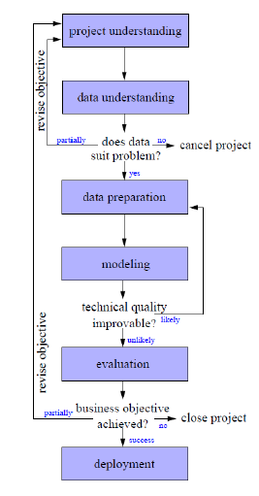Approach:

The Cross Industry Standard Process for Data

Mining (CRISP-DM) model is used to approach this

Business problem. The task is broken down into the

following 6 stages:

1. Project Understanding
2. Data Understanding
3. Data Preparation
4. Modeling
5. Evaluation
6. Deployment
7. Project Understanding

The problem is for a car insurance company.

The customer

The problem is divided into 2 steps. Step 1 is to

predict the policy number by using classification

techniques (like Decision tress, SVM and KNN)

using the train_short.csv. Step 2 is to predict the

policy price using Linear Regression, SVR and

Random Forest methods.